**Meeting Minutes (Group)**

**Attendees:** Qicheng CHEN, Sihan LU, Longwen HU, Yanbing LUO, Chunlong ZHENG, Zhuopu WANG

**Absence:** None

* Found some training datasets online
* Suggest that we might want to train an NLP ourselves
  + Can realize more functionalities (customize)
    - e.g. Debating chat bot, swearing chat bot, etc.
* Plenty of WeChat Mini apps, client-side design might take only a short time

**18:45: Start writing user stories (and prototyping)**

* Discussed if the system needs the functionality of registration? Because mini apps on WeChat do not require registration.
  + Agreed upon registration because it involves privacy risks
  + Then changed our mind, we will make a WeChat mini app which only requires a WeChat account
* Discussed Homepage design
* Discussed if we need to display personal information
* Prototyping already because we think it might be more comfortable to have it visualized about where function should go
* Design "search chat history", "report", etc. interfaces……

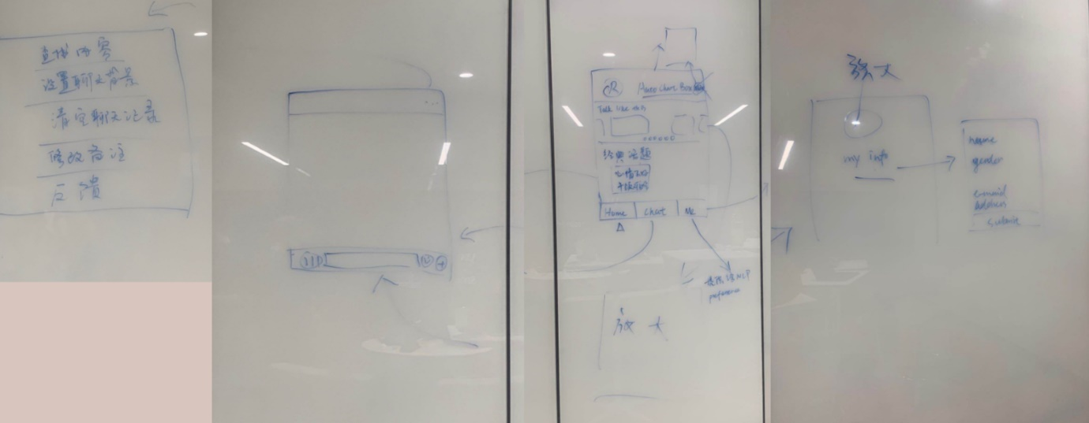

**User Stories:**

1. As a user, I want to log in my account.
2. As a user, I want to be able to type texts to chat with the bot.
3. As a user, I want to be able to send audio file to the bot.
4. As a user, I want to be able to speak to chat with the bot directly.
5. As a user, I want to have some suggested topics to get start with.
6. As a user, I want to be able to search my chat history.
7. As a user, I want to clear my chat history
8. As a user, I want to view information of the developers
9. As a user, I want to give feedback to the developer.
10. As a user, I want to change the bot’s nickname.
11. As a user, I want some chat samples to utilize the functionalities.
12. As a user, I would like to view my photo full-sized
13. As a user, I want to fill in my personal information
14. As a user, I want to change the background of the chat with bot
15. As a user, I want to edit my preference that will have impact on the behavior of the bot
    * See if we can do this later

**21:00: Have different opinions on <<include>> in use case diagram**

* First got the arrowheads reversed
* Then had a discussion on the meaning and use of <<include>>
* There appeared to be a **disagreement** about if every **action enabled by *log in*** should be **included** by ***log in*** or should they be **reckoned as separate use cases**
* At the end, we decide to include actions after logged to ***log in*** (for now, we'll show this to the supervisor later)

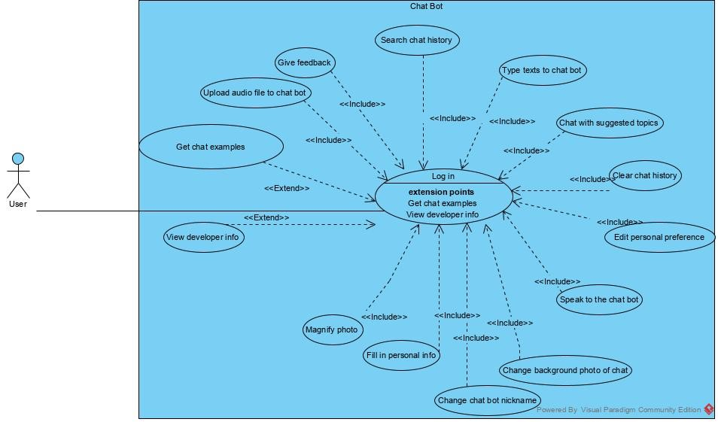

**21:45: Work distributions**

* 3 activity diagrams and sequence diagrams
* **Activity diagrams** are given to:
  + Use case 2 - 4: Yanbing LUO
  + Use case 6 - 7: Chunlong ZHENG
  + Use case 13: Sihan LU
* **Sequence diagrams**:
  + Use case 2 - 4: Longwen HU
  + Use case 6 - 7: Zhuopu WANG
  + Use case 13: Qicheng CHEN

**Next meeting: 2020/10/25 14:00 ~ 17:00**

* Check activity diagrams